Desarrollador IDETEC



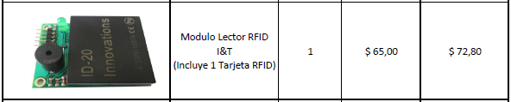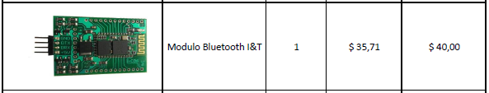

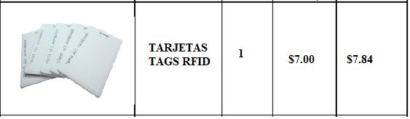

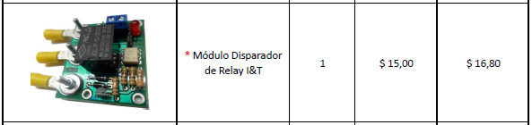

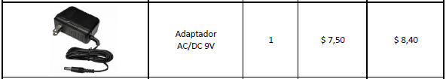

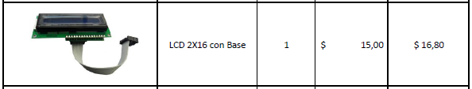

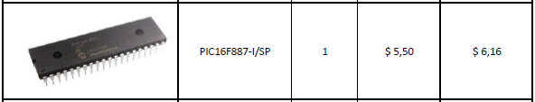

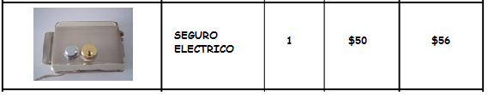

CASE IP 55 $15.00

TARJETA ELECTRONICA $15.00

|  |  |
| --- | --- |
| TOTAL MATERIALES | $256,40 |